Table of Contents

|  |  |
| --- | --- |
| http://www.kcl.ac.uk/ImportedImages/Kingsworldwide/UNC/Kings1.jpg  LOST  Location pinpointing within Kings | Joshua Carley |

Contents

Scope 3

Motivation 3

Objectives 3

Constraints 3

Technical Specification / Justification 4

Platform: 4

Languages: 4

Tasks: 4

Gantt Chart: 6

Bibliography 7

# Scope

## Motivation

King’s College London, founded in 1829, is a public research university with just over 25,000 students[1], and just over 6,000[2] members of staff, covering five different campuses. Each campus covers a vast area, and with multiple floors it can be easy for any visitor, staff, or student member to get lost. Strand Campus alone covers an area of roughly 17,000 m² , and with multiple buildings covering several floors, there comes a point where even campus maps can’t help you.

The College has recently invested £4m into upgrading the wireless facilities available, improving things such better signal strength / coverage[3], providing a great platform that can be used effectively to provide our deliverables.

## Objectives

The aim of this project is to create an application that will allow the user to locate themselves within the Strand Campus of King’s College London, using wireless signal strength data – it will also allow them to navigate to any other area inside Strand Campus with the least amount of confusion possible.

Extensions on this project will include data-collection functionality, to improve the service provided by the app, but also for use of King’s College London to improve facilities. Further extensions to improve the application’s functionality will include social integration features.

## Constraints

Using previously developed location-pinpointing services, such as GPS, is not possible in this project. This is due to several reasons – the unavailability of GPS at subterranean levels, and the lack of precision that GPS provides being important factors. To this end, wireless access points will be used to determine location.

Another important constraint is the data available – whilst the data for location pinpointing and route-planning is to be collected manually, other data that may be necessary for the extension tasks may be difficult to acquire, depending on the College’s security policies.

Finally, some of the functionality provided by the extensions will require a separate server to host the application that will process the data, as well as provide a place to store said data – if a suitable hosting solution cannot be located ( preferably on-site ) then the functionality provided through the extension tasks may be limited.

# Technical Specification / Justification

## Platform:

The project requires that the application be available on an easily portable platform – whilst a laptop may provide additional power, I feel that it would be unnecessary and unwieldy, and so have decided to progress with this as a mobile phone application, specifically for Android smartphones.

I have chosen the Android operating system for several reasons – largest of all is the additional wireless functionality that the Android operating system provides over iOS ( there are no tools for measuring signal strength in iOS ). Alongside this, the Android operating system covers over 80% of the worldwide smartphone market[4], making it the optimal platform for accessibility and data-collection.

## Languages:

The Android programming language is based in Java, meaning that I am restricted to using Java for the mobile application, however, I am also writing the backend server for this project in Java as it is a familiar language that is multi-platform with a large set of pre-existing libraries. This means that I can write one code set for installation on any platform, and also that with so many resources already available, I can put more time / resources into other aspects of the project.

## Tasks:

* Collection of wireless access point data
  + Signal strength
  + MAC address
  + Location of wireless access point
* Create location pinpointing algorithm – using signal strength from surrounding wireless access points to determine distance from points / general location.
* Create path-finding algorithm – most likely using an adjacency matrix and Dijkstra’s algorithm
* Develop Android application:
  + Create user interface
  + Associate wireless points with locations on maps
  + Implement location pinpointing algorithm into application
  + Implement path-finding algorithm into application
  + ( Extension ) Create and implement data collection methods, and resources to send information to back-end
  + ( Extension ) Create and implement data implementation methods – resources to retrieve information from back-end for improvement of the application
    - Use caching to reduce overall data transfer / resources used
  + ( Extension ) Implement social-networking integration – most likely importing events from Facebook
* ( Extension ) Develop Java backend:
  + Implement connectivity between the server and the mobile application
    - Needs to be able to deal with multiple connections simultaneously
    - Needs to be efficient with data transfer / physical resources, considering network bandwidth / mobile data limitations – caching as mentioned above
  + Implement data management – storing information useful to the client in a database, and retrieving it upon request
  + Reporting tools – data for the College needs to be turned into information before it can be useful – methods need to be created for this
    - Information then either needs to be stored or transferred to a location that is more accessible for the College

# Gantt Chart:

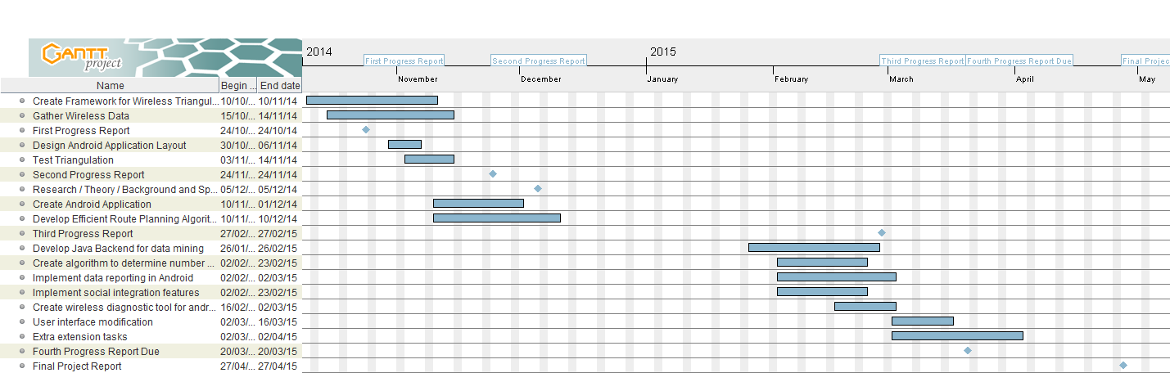

Gantt Chart created using GanttProject software

# Bibliography

(n.d.). Retrieved from GanttProject: http://www.ganttproject.biz/

*King's College London Headcount Summary 2012-2013*. (2012). Retrieved from King's College London: http://www.kcl.ac.uk/aboutkings/facts/ida/stats/HeadcountSummary2012.pdf

*King's College London Profile - 2012*. (2012). Retrieved from King's College London: http://www.kcl.ac.uk/newsevents/publications/Profile-2012.pdf

*Smartphone Operating System Market Share - Q2 2014*. (n.d.). Retrieved from IDC: http://www.idc.com/prodserv/smartphone-os-market-share.jsp

*Wireless Network Upgrades*. (2013, November). Retrieved from King's College London - Internal: https://internal.kcl.ac.uk/news-and-events/news/2013/11-Nov/Wired-and-Wireless-Network-Upgrade.aspx

1. (King's College London Headcount Summary 2012-2013, 2012)
2. (King's College London Profile - 2012, 2012)
3. (Wireless Network Upgrades, 2013)
4. (Smartphone Operating System Market Share - Q2 2014, n.d.)